Laxton
Community Review
& Consultation

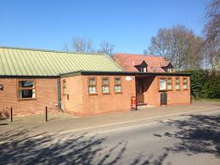

Laxton Community Review Report

Humber & Wolds Rural Community Council were engaged by Laxtton Parish Council to undertake a Community Review after a presentation was given to the Parish Council in October 2015 and they decided to go ahead with the concept in 2016, with a dates to be arranged.

A Community Review is a short and snappy community consultation and engagement tool. The idea of using this technique, is to engage quickly and simply with the community in order to ascertain their views and ideas and from that formulate an Action Plan to take these forward.

The Parish Council at Laxton decide to use the Summer Festival at the Village Hall
to hold a community consultation event on Sunday 4th September. The consultation was designed to look at a range of potential issues within the community.

A second consultation was held at the Village Hall on Saturday 27th November at the Christmas Fair event. Residents who attended the event were asked similar questions to those used in September, in order to get a consistent approach.

Finally in February 2017, a questionnaire was circulated within the village to gain more insights into specific issues. The following report looks at the issues raised and how these might be taken forward by the Parish Council and the community of Laxton.

Three areas were as follows:
Community spirit in Laxton
What residents liked and what could be done to improve Laxton.

To facilitate the consultation, HWRCC came up with three consultation ideas which were used on the three stands they occupied at the Community Events on 11th June and 3rd September 2016.

The techniques used were as follows:
Community Spirit Flipchart with cut out paper ghosts for members of the community to record their ideas about Community spirit and how to improve it.
A quiz for the Summer Festival with opportunities to comment on the likes and dislikes about the community. It was also an opportunity to talk about Laxton in general and what has changed.
Washing Line Survey – to show what residents liked and what needs to be improved in the community.

In addition to the above, the Parish Council circulated a questionnaire to the community in early 2017 to look at some more specific issues. These included:
- What makes your village a good place to live?
- What needs to be improved to make your community a better place to live?
- Which community building is most important to you?
- How frequently do you use them?
- Are you satisfied with the current provision for social or recreation activities in the community?
- What concerns would you like to see the Parish Council resolve on your behalf?
- How could the relationship between residents and the Parish Council be improved?
- Would you support the development of children's play activity in the village?
- Would you be prepared to participate in the development of children’s play activity?
- What is your age and gender? (for the person who completes the questionnaire)
The event in September was well organised by the Village Hall. Food was provided and an obstacle course for the children to compete against the clock. The event was support by a reasonable number of people both local and from neighbouring communities..

The Christmas Fair at the Village Hall in November was reasonably well attended and the consultation received some responses to the questions asked.

Overall the three consultation areas were well used and a number of key themes began to identify themselves from the responses that were received. In many cases the issues are repeated in each of the themes, which helps identify those of major concern to residents.

I have split the comments into the main components of the Community Review.

- Community Spirit in Laxton and what can be done to improve it?

What does it mean to you?

Too much reliance on the same people to organise everything. Need new residents to get involved.
Village Hall and the Pub are bringing people together.

How could it be improved in Laxton?

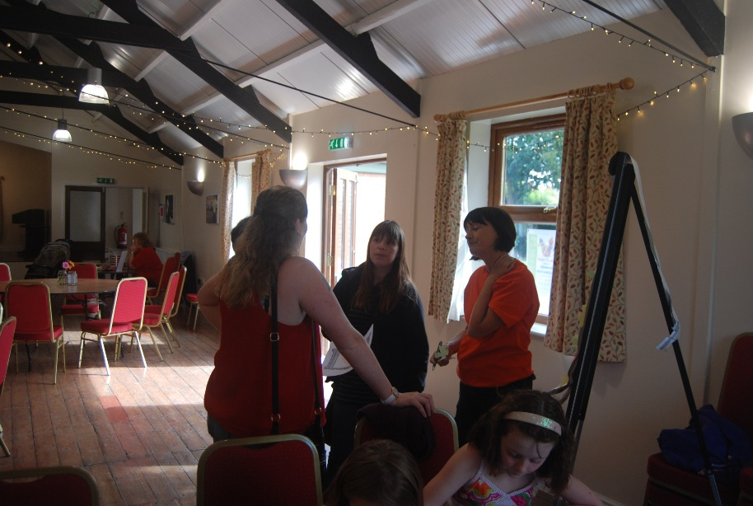
Better communication in the village – what’s on in the village?
Notice Board
Posters through doors, as advertising poor – could use local children to deliver.
A-Board to help advertise events

Children’s pay area

Village Hall not used enough – (kid’s parties?)

(Consultation at Village Hall in September)

Consultation on Transport to identify needs

New blood on the Parish Council – innovate with new ideas.
Place to sit and chat – Quadrangle?

- What’s do you like about living in Laxton?

The likes were many and various and included the locality and rurality of the community. Most people liked the peace and tranquillity of the village, which they also felt it had open spaces and was a safe place to live and bring up children.
The Playgroups were liked and wanted to be kept going.
In general the village was seen as a friendly place to live. The Village Hall and the Church were well liked. The pub was also well liked and from the questionnaire well used.
Community events such as Bonfire Night were appreciated and needed to continue.
The questionnaire showed that residents liked the quality of life, as the village was seen as tranquil, quiet, with little crime, safe and a good place to bring up children. The community is seen as friendly, with good neighbours. The rural situation, the wildlife are all appreciated.

- What do you dislike about living in Laxton?

The main concerns were the slow speed of Broadband provision.
Roads came in for a lot of comments, in particular the state of them and the potholes, as well as long waits at the railway crossing.
Lack of a shop and things to do for kids were also mentioned.

- What would you like to see developed in Laxton?

Youth activities are needed as well as more children to attend the Rocky Club.
More community events and better use of the Village Hall although no explanation for this was given.
Roads, as mentioned above needed to be repaired and more passing places installed.
Again better broadband was requested and phone connections
A bus service to Howden was mentioned, as was a playground
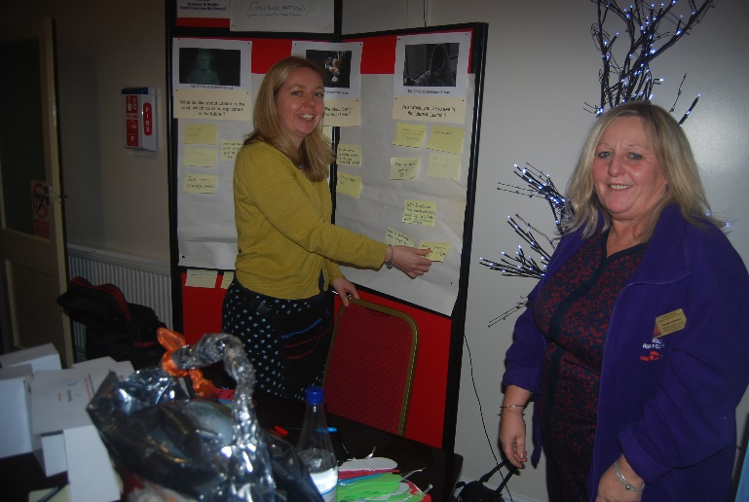
Need for the Village Hall and Church to communicate better with each other and have less competition, to ensure both can thrive.
The questionnaire stated that Dog Poo was a real problems and needs to be dealt with. More waste bins were mentioned.
Improvements to community spirit was mentioned, with ideas such as developing a caring community; village needing all community building to keep a sense of community; connect with the most vulnerable; improve community spirit and encourage greater participation in events from residents.
Transport issues were raised again, in particular, speeding in the village and poor state of roads.
Lack of paly area and activities for children highlighted.
A shop wanted in the village
Better broadband connectivity
Lack of mains gas.

- The Questionnaire

Much of the responses that came from the questionnaire are mirrored in those received on the day of the Community Review. The issue of communication between the community and the Parish Council is highlighted, as are the speeding and other transport issues.

The data from the questionnaire and the consultation at the Village Hall are all included as appendices to this report.

Action Plan (proposed)

Below are some suggested actions which could be taken to address some of the issues identified.

- The first major issue appears to be in regard to the roads in the vicinity of the village which are in a poor state of repair, due to potholes. As has been highlighted in the press recently, this is an issue in most Local Authority areas. Some form of discussions with the Highways Department at ERYC would seem to be the most practical step forward that the Parish Council could take, in order to find out when steps might be taken to repair the roads. As communication has also been mentioned , it would be helpful to inform the community, how any discussion have gone and what the outcomes have been, so that they understand what the Parish Council has been doing and the constraints that ERYC is currently working under.

- Dog Poo issues were also highlighted as a issue in the village. Dog poo bins/rubbish bins in specific locations could help to overcome the issue plus more signs on pavements etc. to warn residents. This could be a quick win for the Parish Council.

- Issues regarding Internet connectivity should be addressed to Steve Howdle at the Rural Team at ERYC. Currently there is some help through the Better Broadband scheme which Steve will be able to give you more details or you can find this on the ERYC website. Mobile phone connectivity was also mentioned and this too could be discussed with Steve.

- The issue of a Play Park for children also been highlighted, as well as more activities for children in the village. There are potential solutions which might help to look at these issues.
  - Phil Jackson at ERYC might be interested in helping older children with activities, as he now has a vehicle designed to go out into the rural communities, so contact could well be worthwhile.
  - Development in the village will depend on residents coming forward to offer helps which can be an issue. Alternatives could be to transport children to other venues where activities are taking place. This would need willing volunteers to provide transport or perhaps hiring a vehicle from Goole Go Far for specific events. Further consultation will need to drill down to discover what demand there is for this idea.

- Better communication with the community was highlighted. A regular newsletter would help to solve this issue as long as it is distributed to all households in the village. The website could be improved to provide more information on activities and community groups, as well as linking to Social Media sites. The Parish Council website has a link to Laxton Parish on Line website, which is not up to date in reference to its content. Some form of diary could also be added which could be populated with event dates and activities taking place in the village, providing a one stop shop for those seeking information. Links to the Village Hall/Church could be provided.
- Parish Councillors need to be more approachable and make efforts to engage more fully with their residents, not just at Council meetings. More visibility means others are more likely to get involved.
- More engagement with the community. Drop-In meeting was suggested in a more social occasion. Open Forum event at the Village Hall, specific invites to the Annual Parish Meeting etc. would help to achieve this, without too much effort.

- Noise from Firework displays at Salt March Hall are also taxing some residents. Perhaps a meeting with the Hall to discuss ways that they can inform the Parish Council and the community on impending displays could also be a quick win for the Parish Council.

- Village needs all community buildings to keep a sense of community and belonging. More community spirit with greater participation from residents to join events that are put on.

APPENDIX

See below for results of the consultations:
Appendix1 – Consultation Results at Summer Fair and Christmas Fair:

ETTON COMMUNITY CONSULTATION – Summer Fair 4th September & Christmas Fair 27th November 2016
What I like about Laxton | What do you dislike about living in Laxton | What would you like to see improved in Laxton
Access to motorway | Slow broadband | Youth Activities
The Pub | Broadband | Rocky Club needs more children and help
Pub: fizzy drinks | Transport in and out (need a car) | Youth activities x2
Pub active and vibrant | Pot holes in the road (big) | Community events (fireworks etc.)
Pub x2 | Railway crossing (16 mins) | Events
Lanes & open spaces | Shop | More events at the Village Hall
Quiet and peaceful safe community | No shop | Keep up with events
Countryside | Not a lot of things for kids to do | More of the community using the Village Hall
Safe area | More for kids to do | More people attending events at the Village Hall.
Laxton was such a lovely place to grow up and feel safe. |  | Poor road maintenance (how work is done)
All the lovely community events and the pub |  | State of roads (side of roads) x2
Peace & quiet |  | Poor state of roads in and out needs attention
Free fun things - tree swing etc. |  | No passing places
Nice place to brings kids up |  | Village broadband/satellite  Better phone supply (connection)
Quiet, nice safe place for kids to grow |  | Computers
Friendly people |  | Better Broadband
Friendliness |  | Better Broadband
Community |  | Church and Village Hall need to communicate more
Good village spirit |  | Village events should be more coordinated not competing
Keep the Playgroup going! |  | Bus service (x2)
Playgroup |  | Links to Howden x 2
Village Hall. |  | Playground - (where residents walk their dogs (land for sale)
Village Hall x2 |  | Playground.
Village Hall activities - especially the plays. |  | Playground for children
Church |  | Shop
Keep events going |  | Shop: social space brings people together
Bonfire Night etc. |  | Shop - essentials, Post Office, newspapers etc. (use pub?) Price is an issue - will pay more for stuff?
 |  | Somewhere informal for people to come together & chat (like old blacksmith's shop)
 |  | Summer Day
 |  | Keep fit classes
 |  | Better Railway crossing
 | Children's consultation
 | Likes | Dislikes
 | Going to Rocky Club | Lots of village events to take part in
 | I like the play park | Getting a play park
 | I like Wellibobs Nursery | Having a play ground
 |  | Playground with fireman’s pole

Community Spirit in Laxton
What is it to you? | How good is it in Laxton? | How can it be improved?
More a commuter village - now missing focus | Pub doing a good job. Local person | Communication of What's On in village could improve
New people moving in and not getting involved | Pub - new people - most there? | Notice Board and A Board
Always the same people who organise and come to things, "Can't be bothered attitude" | Excellent food at pub - Open Mic night etc. | Posters though the door works
Reliance on one person to do everything |  | Use of A board to advertise things
VH and Pub doing very well |  | Advertising poor - kids deliver leaflets?
Pub brings people together - Local people have taken it over. |  | Play area needed for kids
Pub brings people together - Local people have taken it over. |  | Village Hall not used enough - Youth activities?
Come to Village Hall when there is something I want to come to. |  | Village Hall could be used for kids parties from Howden
2/3 years ago consultation but only Yoga Club seems to have come out of it. |  | Develop a place to sit and chat - e.g. Quadrangle?
Whose who on Parish Council/Village Hall committee
Representation on Parish Council - does it represent current village?
Vicar's involvement - High profile?

Appendix 2 – Data and Responses from questionnaire.
Available in hard or electronic copy from the Parish Council

